**Jenkins jobs And bitbuket Integration :-**

1. 1. Install Visual Studio on jenkins machine.
2. 2. Install Service fabric on jenkins machine.

After installation of service fabric, tha service fabric icon show in left side notification bar, right click on that and set switch cluster mode to 1 node.

1. 3. Install Microsoft DotNet Core 1.0.1 on jenkins machine.
2. 4. Install git on jenkins machine.
3. 5. Install Msbuild on jenkins machine.
4. 6. Download nuget.exe ( *Just Download* )
5. 7. Install java in on jenkins machine.

*Download java jdk for Windows using following link :-*

http://www.oracle.com/technetwork/java/javase/downloads/jdk8-downloads-2133151.html

Write click on MyComputer --> Go to Properties --> Change Setting --> Adavanced --> Envirnment Variables.

**In User variables :--** click on New Button --> Enter the Java path as per follow

Variable name :- JAVA_HOME

Variables value :- C:\Program Files\Java\jdk1.8.0_144

**In System Variables :--**

click on path variable --> click on edit --> enter the java bin path with semi colon --> click on OK

For example :-> ;C:\Program Files\Java\jdk1.8.0_144\bin

**Check using Following Command :-**

> javac -version

or

> java –version

1. **8. Download Jenkins.war file & Download apache-tomacat zip file**

After the Download extract any location which you want.

Copy the Jenkins.war file and Pest In apache-tomacat /Webapas Folder.

1. **9. Start the tomacat server**

For that go to apache-tomcat /bin folder, open the terminal from this location and run the catalina script using following ways

>.\catalina.sh start

Or

>.\catalina.bat start

1. **Open browser** and first check your tomacat server running or Not

http://<Ip_Address>:8080

then check your jenkins Server running or Not

http://<Ip_Address>:8080/jenkins

1. The above command will make Jenkins accessible at **http://<IP>:8080/jenkins** in your web browser. Upon first launch you’ll be guided through a wizard for configuration.

**Note** : jenkins directory may be diff in your case so first varify tha jenkins directory.

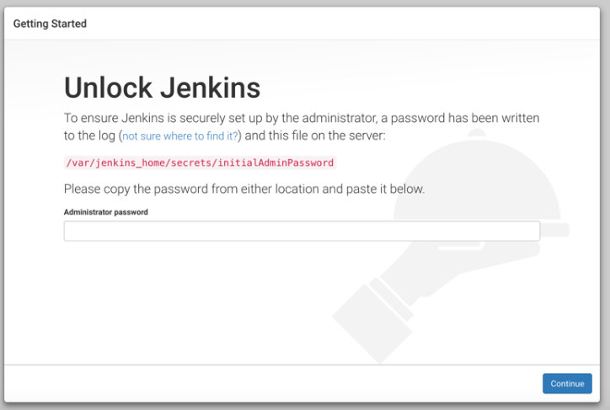

1. After providing the password as per the instructions on the screen, you’ll be asked about the installation of Jenkins plugins

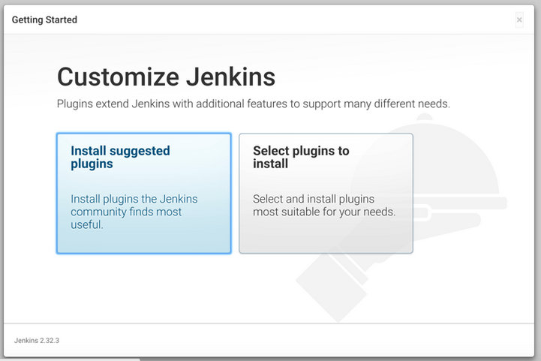

1. We’re going to start by installing the suggested plugins and then install extras later. It may take some time, but after the suggested plugins have been installed you’ll be prompted to set up your first administrative user account.

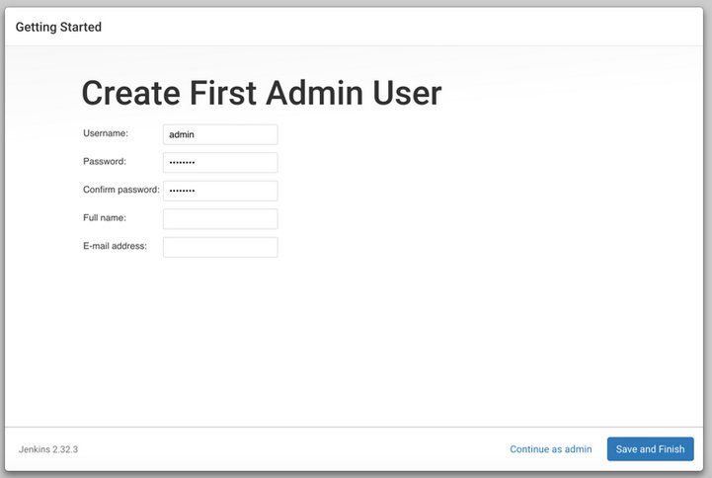

You can choose to create an administrative user, or continue to use the generated password when working with Jenkins. After creating an account, Jenkins is ready to be used. Before we create our first workflow, or job, we need to install an extra plugin.

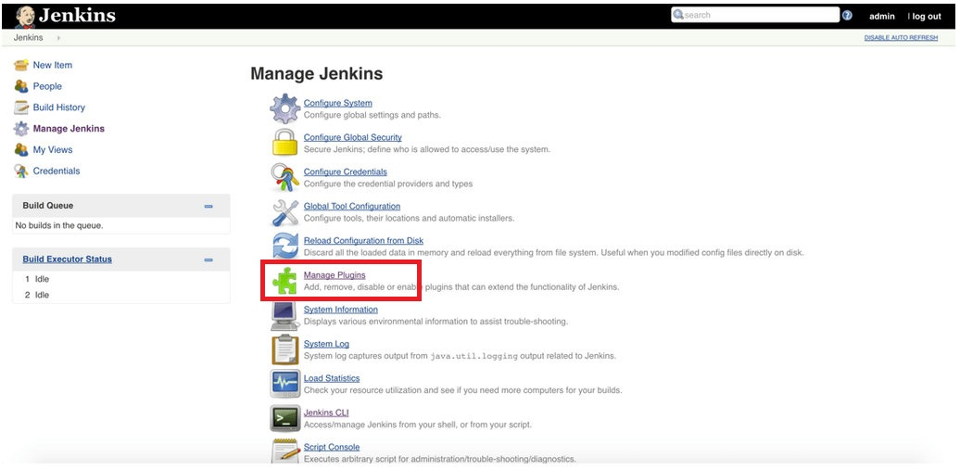

10. Add Jenkins Plugin like :-

1. Git (bitbucket)
2. MS build

c. Windows powerer Shell

d. Email exntion

e. NPM build

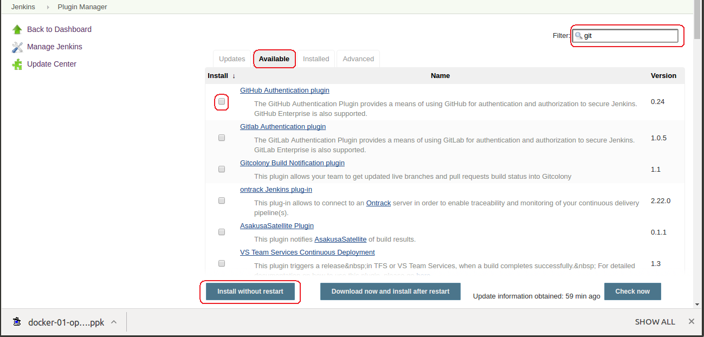

1. **11. Go to Manage jenkins – Configure System**
2. Set the Git , MSbuilt path in Jinkins for that, Go to Manage jenkins – Global Tool Configuration

|  |
| --- |
|  |

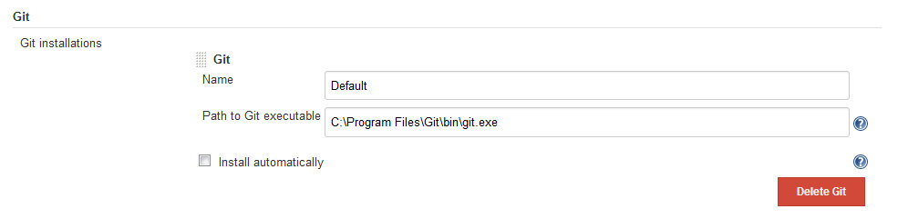

|  |  |
| --- | --- |
|  |  |

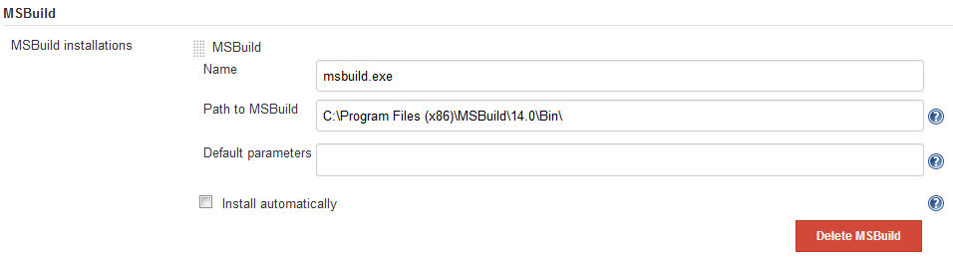

Open your browser & enter url as below.

http://ip-add-of-server:8080/jenkins

you will get page as follows.

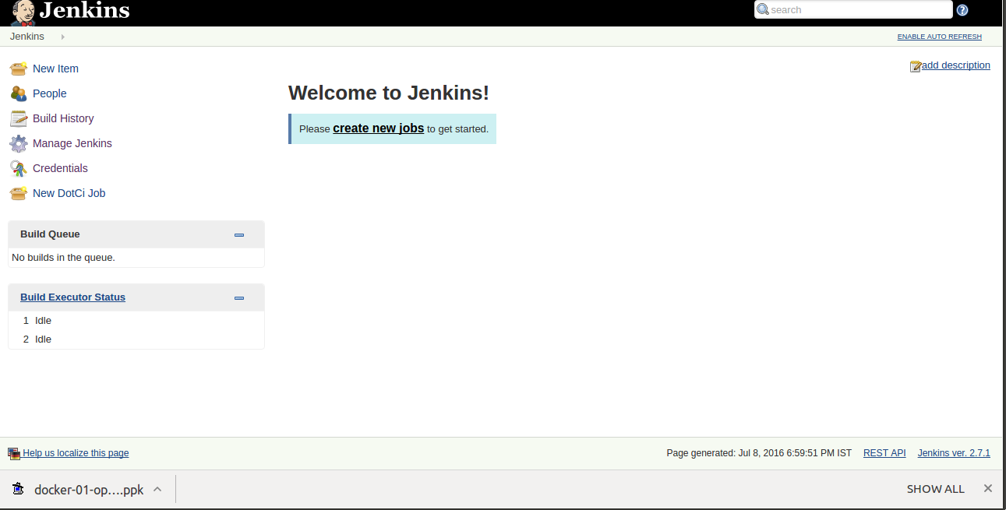

***Now, Creating New jobs in jenkins :-***

**1. First of all, login to your Jenkins server, we have to create jobs for Vision2realitycustomer .**

**Following are steps to create new job Vision2realitycustomer.**

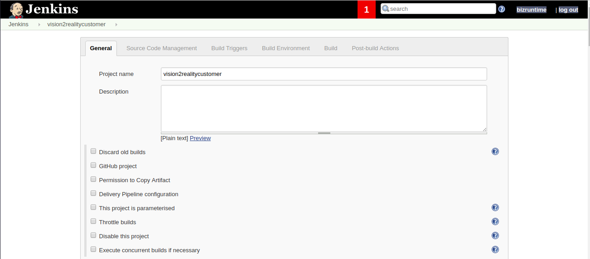

**2. Give bitbucket url of the project and pasword.**

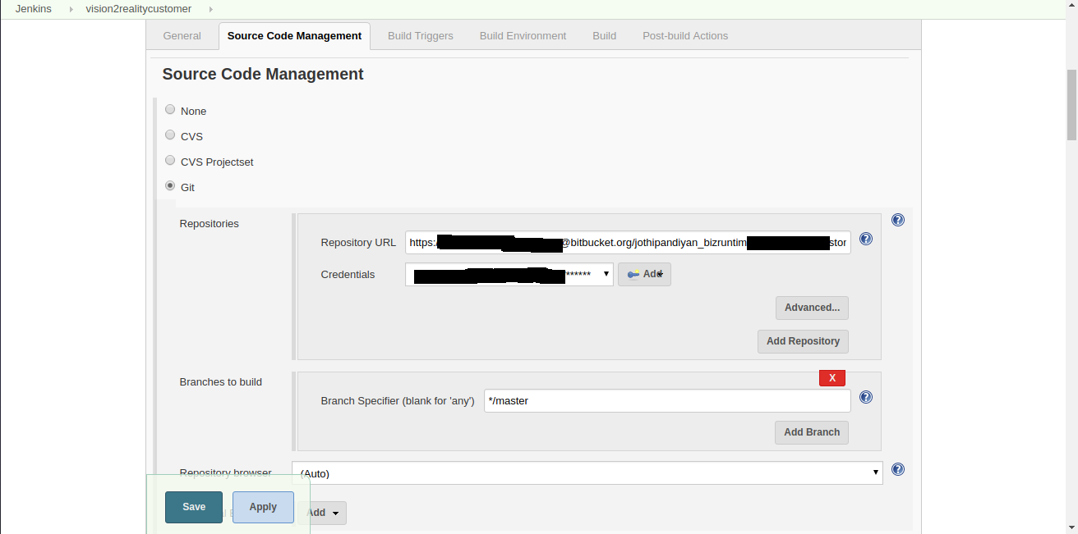

**3. When code is pushed to bitbucket jenkins should trigger the job.**

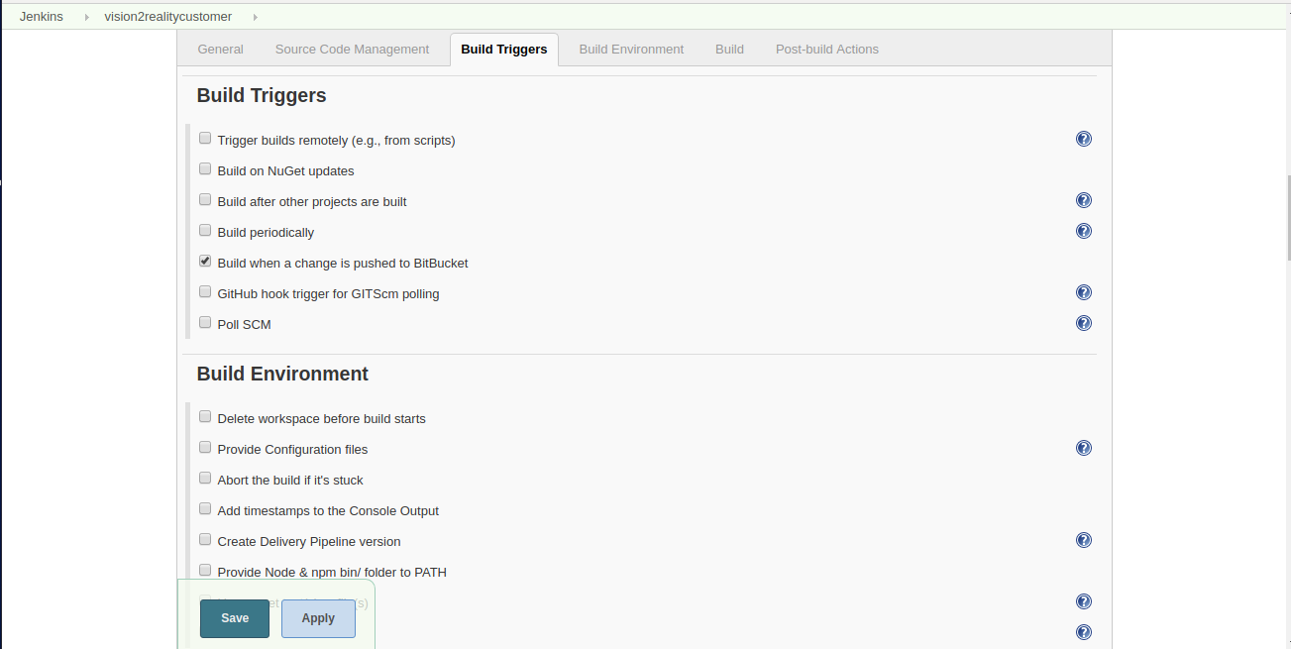

**4. To build the code required configuration has to made.**

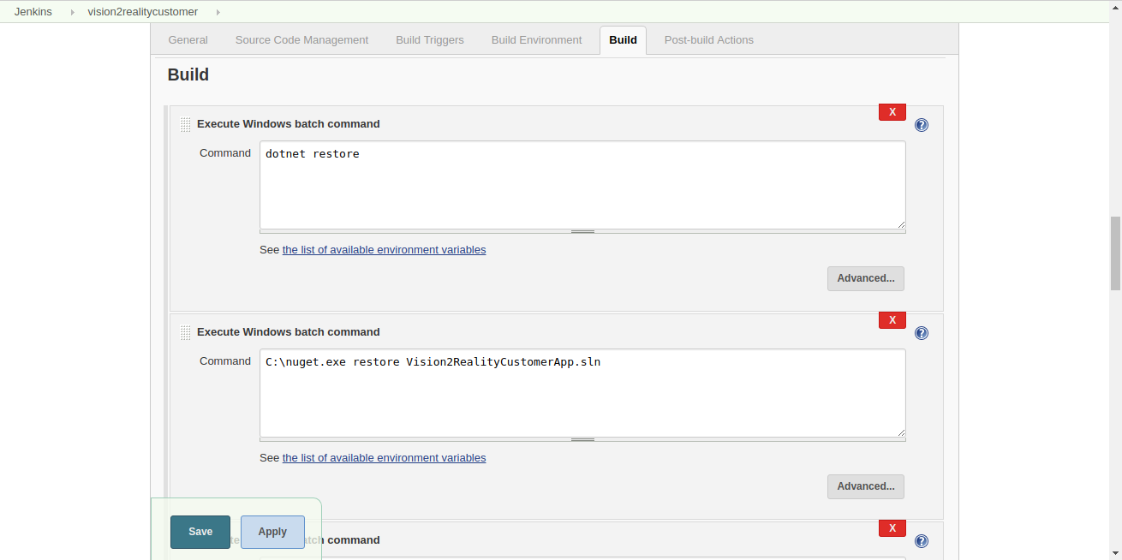

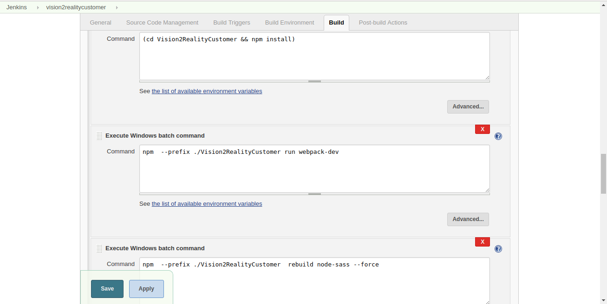

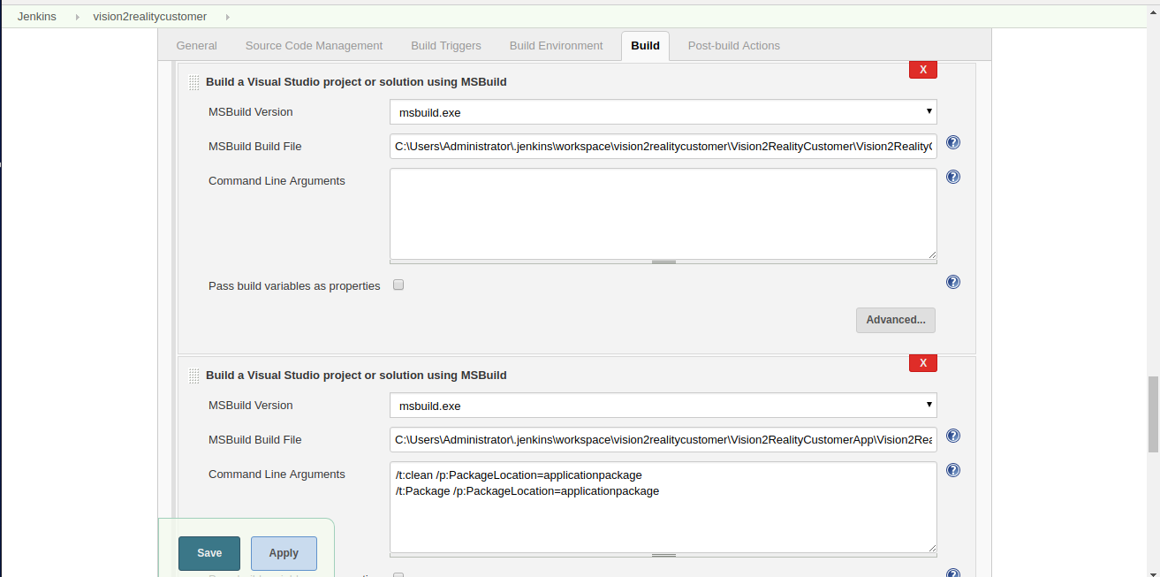

**5. After every build to give append number on build job.**

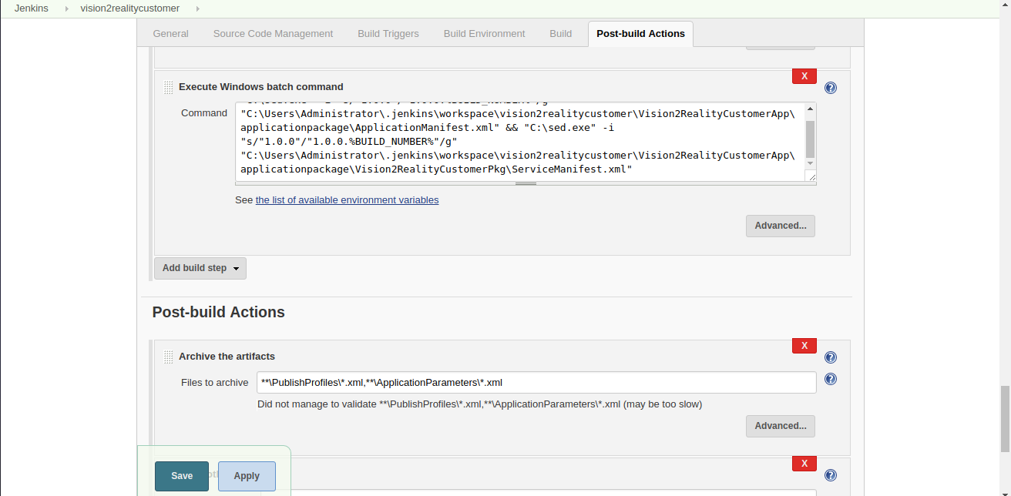

**6. After build code is next publish job will trigger.**

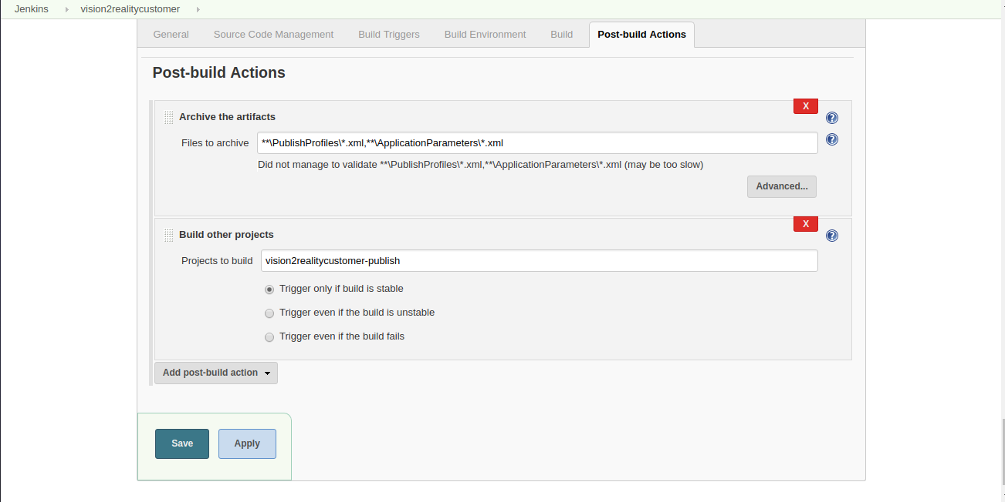

**7. New JOB of PUBLISH, Build CODE to Service Fabric.**

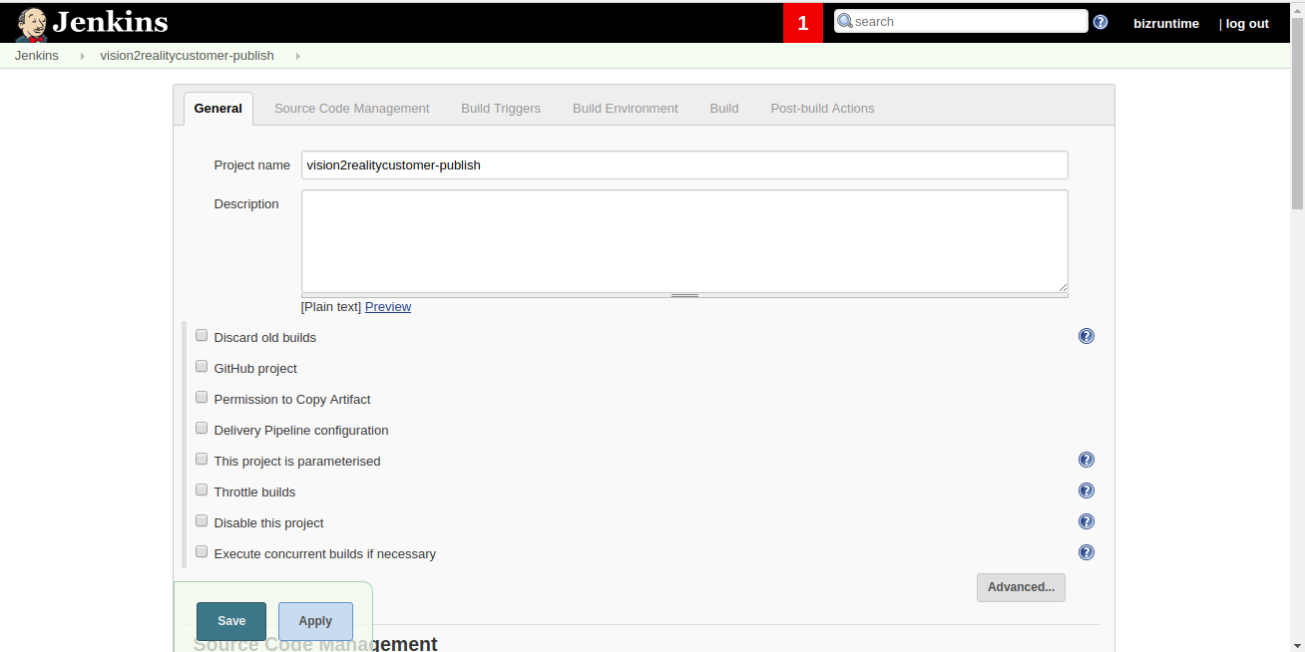

**8. Path of the Scritp ,to execute to publish build code to service fabric.**

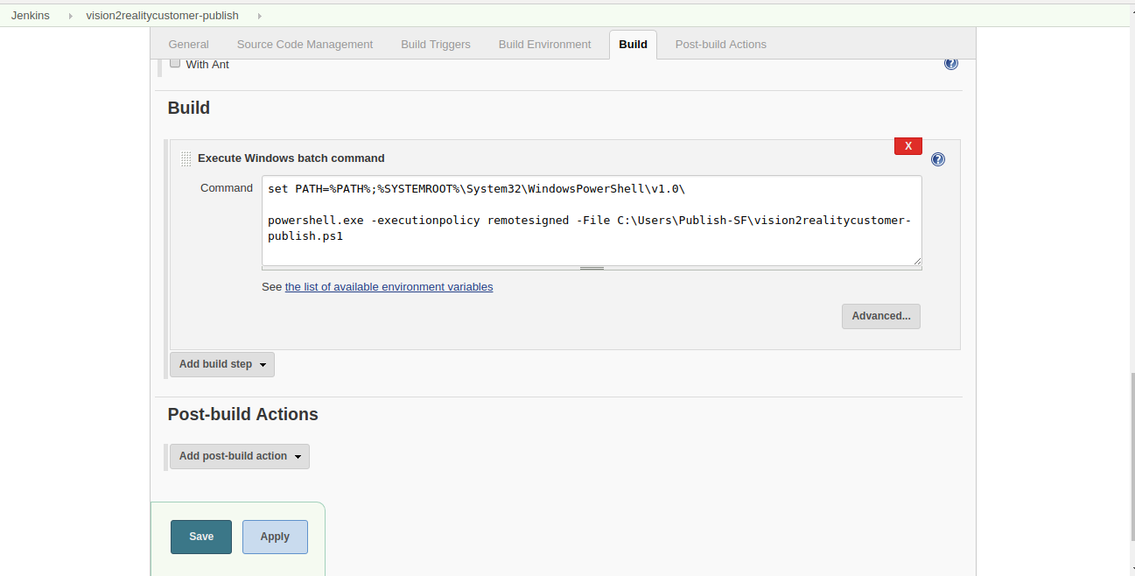

**How to Configure a Jenkins build process by a bitbucket push**

a. This time we will cover how the build process is automatically started when a contributor pushes to the respective Bitbucket repository.

b. To be able to trigger the build process by Bitbucket, you have to configure the

Jenkins instance which should be triggered after the push. For this purpose the

Jenkins web hook URL is required and must be submitted in the Bitbucket project.

c. In the next step, enter your hook URL in the Bitbucket project. Thereto, go to your Bitbucket project settings and click on “Webhooks”. Press the “Add webhook” button give name and set url of jenkins and “save”..

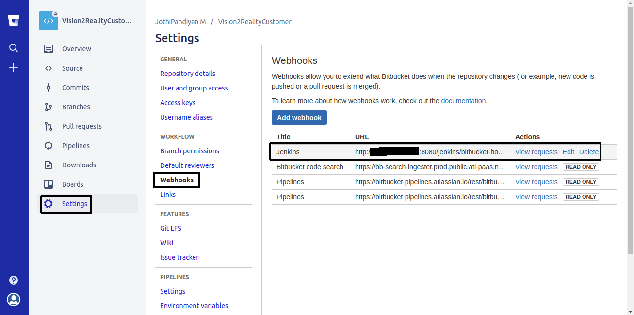

d. Now ,Once code will get push into repository . Jenkins will build job.

